Lesson plan

Unit 13 | Lesson: 39 | An afternoon out

Date :
Class: 6th form
Date :
Class: 6th form
Objectives:
By the end of this lesson pupils should be able to:
- Ordering food and drinks.
- Buying & selling
New language:
Vocabulary : to bay – to sell – drinks – sandwich – ice-cream – juice – menu – salad – soup – coke
Structures: The present progressive (review)
Pronunciation: Vowels in minimal pairs
Teaching aids :
A tape recorder / pictures
Stage | Procedures | Time
Warming – up |   Teacher asks different pupils to say the last song (Where is the zoo?)  Teacher asks pupils to take their slates and invites them to write some words : oranges – I drink milk everyday – how much is one kilo of bananas (dictation) | 10mn

Presentation | Teacher presents a picture then she asks: Do you know this place? Name it … What the people are doing?  Pupils try then teacher introduces: A park / a public garden  Teacher asks: What do you see?  Pupils try then teacher introduces :  There are many sellers and many people.  They are baying drinks / ice-cream /sandwich / apples  Pupils use new words in sentences using some pictures presented on the black board.  Teacher presents a picture then she asks: Do you know this place? name it …  Pupils answer it’s a restaurant and we eat there  Teacher presents a picture of food then she asks : What’s the name of this food ?  Pupils try then the teacher help them : salad/soup/meat/fish/  Pupils use new words in sentences . | 25mn
Practice | 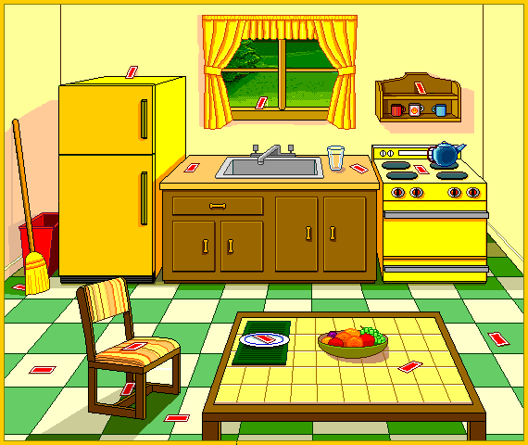  Teacher invites pupils to open their books at page194  Teacher reads .  Pupils follow on their books.  Then pupils read the text to.  Teacher asks pupils to read then do the activities on page 195/196/197/198  Then check and correct | 25mn

